

Law and Governance of a Global City:

17th-century Amsterdam

Friday and Saturday December 9-10, 2022

UvA Roeterseiland campus
A3.01

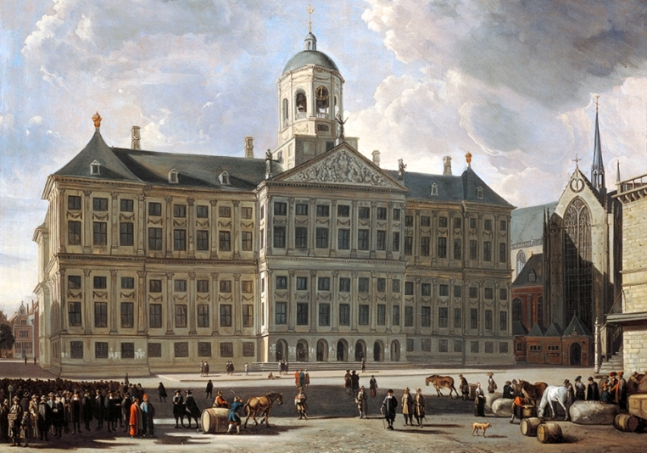

Amsterdam’s Town Hall (1655)

This workshop is aimed at the preparation of a collection of essays regarding the law, governance and globalization of the city of Amsterdam in the seventeenth century. The city of Amsterdam grew to prime importance in this period. The wealth and attractiveness of the city mounted, in tandem with its rising global impact. Merchants flocked to the city, and investments were made in the Amsterdam-dominated Dutch East India Company, which controlled territories overseas. The globalization in which the city and its inhabitants were partaking had effects on the city’s governance and self-portrayal. Amsterdam came to present itself as a world city and as a city of commerce with international influence. However, all this was not without its problems. Amsterdam was a city that was open to newly arriving religious and expat communities, but nonetheless strived towards keeping control. This resulted in challenges for its government. The aim to accommodate for the rights of different groups was balanced with a goal of public management. The efforts of legislating the different communities were on closer look not always inspired by equality. Some groups received more rights than others. A search for oversight also related to the city’s institutions. Merchants made use of the city’s governmental and legal infrastructure, for example the aldermen’s certifications of debts and contracts as well as its courts. The Insolvency Chamber was an important institution that channeled information on the financial situation of indebted merchants and facilitated agreements between insolvent debtors and their creditors. Yet, traders were not only resorting to municipal institutions; notaries became increasingly popular. Merchants were using a combination of legal institutions and instruments when pursuing their business goals. They also built their networks around family ties and trust was as important as legal norms. Furthermore, the colonial ventures of the Dutch Republic, in which Amsterdam and its merchants were deeply involved, raise questions on specific contribution of the city and its government. The mercantile success of Amsterdam was for a large part due to the financing of oppressive activities overseas. As a result, the process of globalization in the seventeenth century must be assessed while taking this into account as well.

Friday 9 December 2022

10am Welcome

Session 1: Diplomacy, international relations and networks

10h05-10h35 Tessa de Boer (Leiden University), Used and Abused: Diplomatic Status in Early Modern Amsterdam

10h35-10h55 Dave De ruysscher (Tilburg University), Sovereignty Thinking and the Legal Self-Image of the City of Amsterdam (16th-17th Centuries)

10h55-11h10 coffee break

11h10-11h40 Ramona Negrón (Leiden University), Amsterdam merchants in the Spanish Americas, 1580-1700

11h40-12h00 Arjan de Koomen (University of Amsterdam) and Janne Nijman (University of Amsterdam) Local Government and Universal Laws: Interpreting the Iconography of the Amsterdam Town Hall

12h-12h30 wrap up of the first session

12h30-14h lunch

Regulating merchant and religious communities

14h-14h20 Marc de Wilde (University of Amsterdam), Regulating Diversity in 17th Century Amsterdam: The 1616 Regulations Regarding the Jewish Population

14h20-14h40 Bart Wallet (University of Amsterdam), A Nation Apart. Legal Status and Internal Dynamics of Amsterdam Ashkenazim

14h40-15u10 Victor Le Breton Blon (University of Bretagne Sud), Amsterdam as Exchange Centre, from an International Perspective (Later 17th Century)

15h10-15h30 wrap up of the second session

15h30-15h45 coffee break

Amsterdam’s market and stock exchange

15h45-16h05 Maurits Den Hollander (Tilburg University), The Moral Dimension of Insolvency in 17th Century Amsterdam

16h05-16h25 Johannes W. Flume (Freie Universität, Berlin), Innovating Market Exchange: The Amsterdam Stock Exchange as a Blueprint for Modern Derivative Markets

16h25-16h45 Vincent van Hoof (Radboud Universiteit), Credit and Legal Innovation in 17th-century Amsterdam.

16h45 coffee break

17h00-18h15 wrap up of the third session

Saturday 10 December 2022

Visit of the Town Hall of Amsterdam (Paleis op den Dam)

